Project Planning Phase
Project Planning Template (Product Backlog, Sprint Planning, Stories, Story points)

Date | 25 October 2026
Team ID | Individual
Project Name | EV Market Analysis
Maximum Marks | 8 Marks

Product Backlog, Sprint Schedule, and Estimation (4 Marks)
Use the below template to create product backlog and sprint schedule
Sprint | Functional Requirement (Epic) | User Story Number | User Story / Task | Story Points | Priority | Team Members
Sprint-1 | Sales Performance Analysis | USN-1 | As a Market Strategy Director, I can view total sales and annual sales by vehicle category so that I can see which categories contribute most to annual sales. | 5 | High | Individual
Sprint-1 |  | USN-2 | As a Market Strategy Director, I can see the top 10 manufacturers by sales so that I can identify the leading manufacturers. | 5 | High | Individual
Sprint-1 | Customer Satisfaction | USN-3 | As a Market Strategy Director, I can compare average customer rating across vehicle categories so that I can evaluate satisfaction by product segment. | 5 | Medium | Individual
Sprint-1 | Growth & Technology Trends | USN-5 | As a Market Strategy Director, I can view battery technology adoption and average range by vehicle category so that I can plan the product portfolio. | 5 | High | Individual
Sprint-2 |  | USN-4 | As a Market Strategy Director, I can view the top 5 sales growth by year so that I can identify high-growth market segments. | 4 | High | Individual
Sprint-2 | Manufacturer Competitive Analysis | USN-6 | As a BI Manager, I can see the market share of the top 10 manufacturers so that I can identify competitive advantages. | 4 | High | Individual
Sprint-2 |  | USN-7 | As a BI Manager, I can see sales by manufacturing country on a map so that I can understand geographical production trends. | 4 | Medium | Individual
Sprint-2 |  | USN-8 | As a BI Manager, I can compare rating vs sales for each manufacturer so that I can position products and recommend market entry to clients. | 4 | Medium | Individual
Sprint-2 | Battery & Range Research | USN-9 | As a Research Analyst, I can compare battery technologies and their range over model years so that I can find technology trends. | 4 | High | Individual
Sprint-3 |  | USN-10 | As a Research Analyst, I can view the annual sales trend and CO2 emissions prevented so that I can assess the impact of EV adoption on sustainability. | 8 | Medium | Individual
Sprint-3 | Interaction & Navigation | USN-11 | As a user, I can filter, highlight and navigate between the two dashboards so that I can explore the data for my own question. | 8 | Medium | Individual
Sprint-3 | Data Refresh & Publishing | USN-12 | As an Administrator, I can refresh the data source and republish the dashboards so that users always see updated figures. | 4 | Low | Individual

Project Tracker, Velocity & Burndown Chart: (4 Marks)
Sprint | Total Story Points | Duration | Sprint Start Date | Sprint End Date (Planned) | Story Points Completed (as on Planned End Date) | Sprint Release Date (Actual)
Sprint-1 | 20 | 6 Days | 26 Oct 2026 | 31 Oct 2026
Sprint-2 | 20 | 6 Days | 02 Nov 2026 | 07 Nov 2026
Sprint-3 | 20 | 6 Days | 09 Nov 2026 | 14 Nov 2026

Velocity:
Imagine we have a 10-day sprint duration, and the velocity of the team is 20 (points per sprint). Let’s calculate the team’s average velocity (AV) per iteration unit (story points per day)


For this project: sprint duration = 6 days, velocity = 20 story points per sprint, so the average velocity (AV) = 20 / 6 ≈ 3.33 story points per day. Total work = 60 story points over 3 sprints (18 days).
Burndown Chart:
A burn down chart is a graphical representation of work left to do versus time. It is often used in agile software development methodologies such as Scrum. However, burn down charts can be applied to any project containing measurable progress over time.
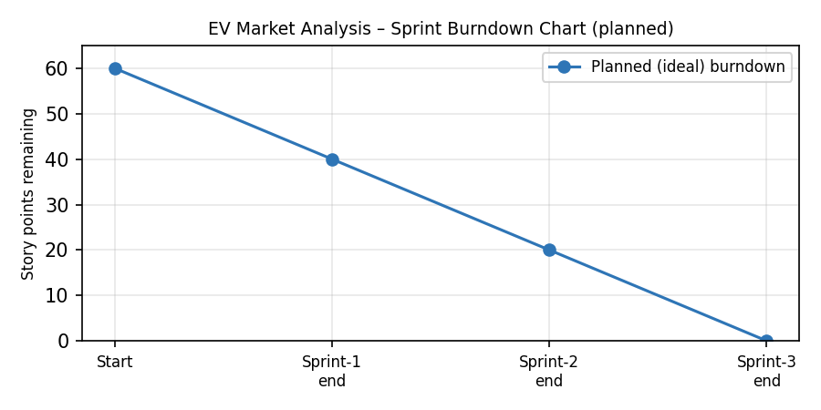
https://www.visual-paradigm.com/scrum/scrum-burndown-chart/
https://www.atlassian.com/agile/tutorials/burndown-charts

Reference:
https://www.atlassian.com/agile/project-management
https://www.atlassian.com/agile/tutorials/how-to-do-scrum-with-jira-software
https://www.atlassian.com/agile/tutorials/epics
https://www.atlassian.com/agile/tutorials/sprints
https://www.atlassian.com/agile/project-management/estimation
https://www.atlassian.com/agile/tutorials/burndown-charts

